Governance

Governance on Azure is a set of rules, policies, and roles to define acceptable use of Azure resources.

Azure has several tools and services to help you implement adequate governance.

Governance in Azure is like having rules and tools to manage and control everything you do in your Microsoft Azure cloud environment.

1. Azure policy

* It is used to create polices
* governance validates that your organization can achieve its goals through effective and efficient use of it.
* A policy is a set of rules
* A policy is a set of rules to ensure resources are compliant (Compliant means willing to do what someone asks or orders you to do.)

1. Role Based Access Control

* Role-based access control lets you define which users have access to specific Azure resources, what they can do with those resources, and what areas they have access to.
* One of the best practices for any computer infrastructure is to give users the minimum access they need.
* you can target specific use cases for assigning access.

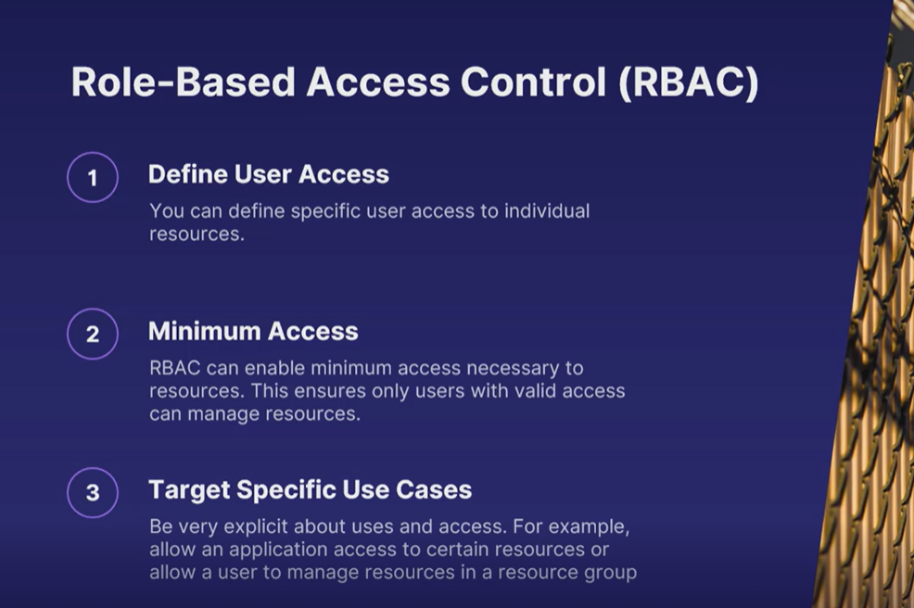

Role assignment in RBAC::

* Security Principal

which is an object that represents what type of entity can get access to the Azure resource. This could be a user or group of users.

* Role definition

A role definition is a collection of permissions and lists the operations that can be performed, such as read, write, and delete.

* Scope

Scope is the set of resources that the access applies to.

>>>> for example,

you want a specific role assignment to have only access to a specific resource group.

Role assignment is the process of combining those three properties to grant access to Azure resources.

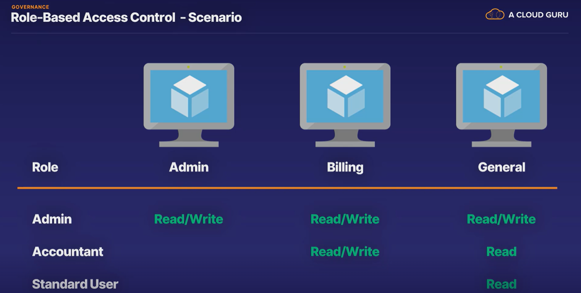

1. Locks

You might want to ensure that a specific resource will not be changed or deleted, which is what locks are for.

* A lock can be assigned to a subscription, resource group, or resource level.
* A lock can be of type delete or read-only.
* A lock needs to be removed before the locked actions can be performed again.

1. Azure Blueprints

* Blueprints are templates for creating Azure resources.
* It is a blueprint for everything you need to deploy for a standard cloud environment on Azure.
* Azure Blueprints are a service from Microsoft Azure that allow you to create reusable templates for deploying and governing cloud environments.

1. Cloud adoption framework

* This is a collection of documents that takes you through every step of the journey towards the cloud.
* You get guidance on how to define strategies for adoption, planning the move, what it means to be ready for the cloud, reasons for adopting the cloud, improving your governance and establishing practices around it, and managing a living, breathing cloud architecture.
* Governance in particular is important to make a smooth transition to the cloud, and the Cloud Adoption Framework is super helpful to achieving this.

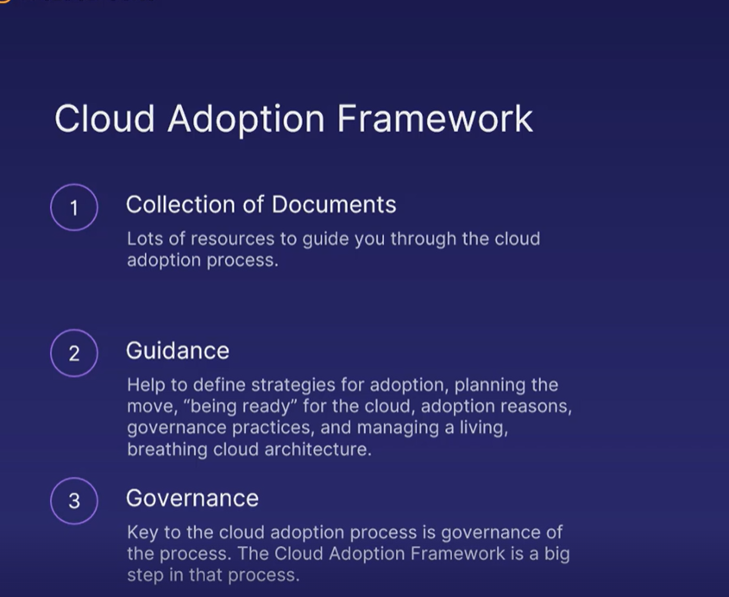

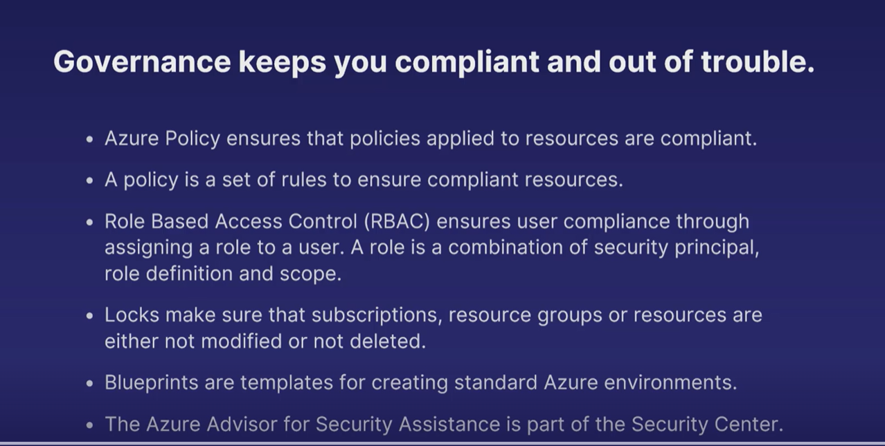

Azure Monitor

Azure monitor helps you find resources that aren’t performing 100%

Telemetry – it is information about how services or devices performing. This info is sent to a central point(Azure monitor) for further analysis.

In azure the telemetry all goes into Azure Monitor, which will gives this dashboard in the azure portal.

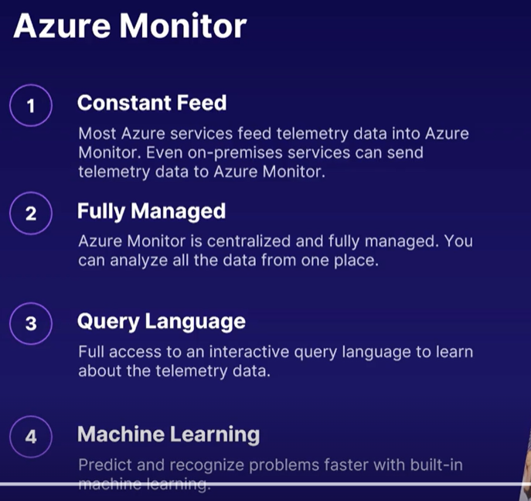\

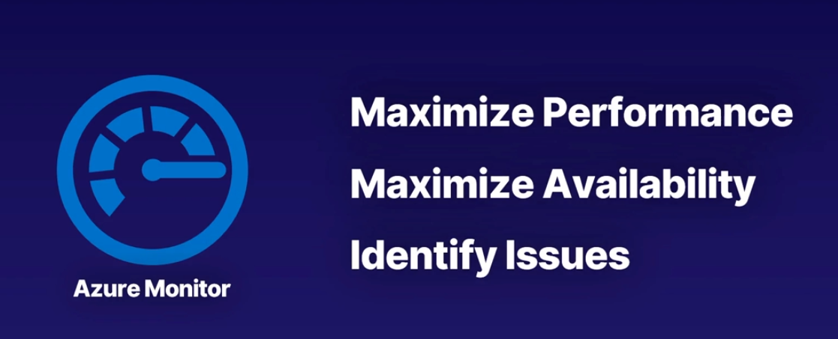

The outcome of using Azure Monitor should be, maximize performance, maximize availability of your Azure applications, and identify issues before they even become problems.

Monitoring tools::

Azure includes multiple monitoring tools to gain full visibility into your Azure environment

1. Log Analytics
2. Application Insights
3. Azure Monitor Alerts

Log Analytics:::

Azure Monitor generates a lot of logs and telemetry data

Log Analytics is a tool in the Azure portal that allows you to edit and run log queries from data collected by Azure Monitor logs.

A large number of pre-built queries are provided. However, you can create your own custom queries as well. Regardless of your query method, these queries are in what is known as Kusto Query Language or KQL format.

Application Insights:::

* It gives you performance insights for web applications.
* This works with only web based applications only
* Applications insights service is applicable for both azure and non-azure resources
* But we need to install an agent to get tied to that resource to application insight service

Use scenario is like::

` Find performance bottleneck in web application

` Discover how users are using the website

Application Insights for your web-based applications is able to answer valuable questions such as

how are our users using our web-based application?

Where our different performance bottlenecks?

And if our website is getting errors,

why are we getting those errors?

Azure Monitor Alerts:::

If something in your Azure environment breaks, it sends out an alert, so someone can do something about it. More specifically, it sends out notifications in response to different unexpected events.

Ex:

1. VM unresponsive
2. VM using excessive CPU
3. Application running very slow

In monitoring alerts there main 2 components are there

1. Alert rule

The alert rule is the trigger that is met before it sends out a notification.

The components of an alert rule or the trigger - Monitored resource, Monitored telemetry, Conditions to trigger alert, Assigned severity

Rule example ::

Monitored resource : VM

Monitored telemetry : CPU utilization

Condition : >90% CPU for % min

Severity : 2- Warning

1. Action Group

Action(s) taken when rule is triggered

The components of an action group ::

* include notification targets which can be an email or SMS to human-based personnel.
* Maybe you have an SRE team that needs to be notified once an application is not performing as expected.

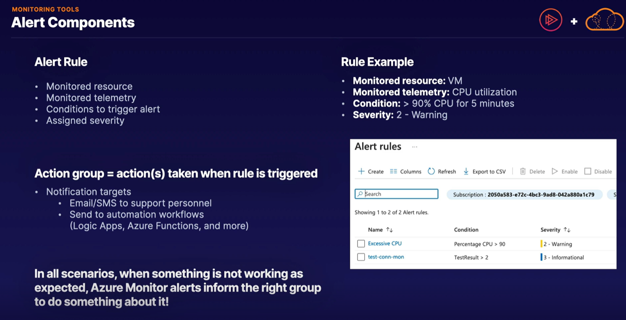

Azure Service Health:::

* Azure platform needs to be updated and maintained just like any other computing infrastructure.
* While this is often done without you even noticing, it is important that you can mitigate the risk and take necessary steps to protect your infrastructure and applications.
* In Azure, Service Health dashboard is there.
* Azure Service Health notifies you about any planned and unplanned incidents on the platform.

Features of Azure Service Health

* Personalized dashboard
* Custom alerts
* Real-Time Tracking
* Free service

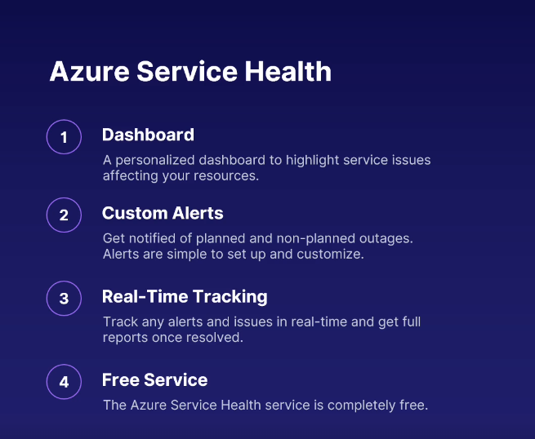

Compliance::

Regulations, legislation, rules, and guidelines, are all things you need to adhere to, follow, and implement. If you don't, you get in trouble, which is why compliance on Azure is so important.

1. General Data Protection Regulation (GDPR) :

* GDPR applies to EU residents; it does not apply globally.
* The main objective of the GDPR is to protect individuals with regard to the processing of their personal data.
* It will give you control of personal data to individuals, instead of company owning it.
* It also forces companies to put a lot of measures in place to protect the data and provide tools to users for managing that data.

1. ISO standard (International Standardization Organization) :

* In ISO, lot of different categories of compliance are there.
* Generally, it is compliance with quality and customer satisfaction.
* There are also other ISO standards for compliance, including food safety management and environmental management.

1. NIST (National Institute of Standards and Technology) :

* NIST focuses purely on tech industry.
* In particular, on information security frameworks for US federal agencies.
* The NIST guidelines are developed in such a way that compliance with NIST often ensures compliance with multiple federal US regulations.
* One of the most popular NIST frameworks is the Cybersecurity Framework.

Azure Compliance Manager::

The Azure Compliance Manager is a tool to help you ensure compliance on azure.

/ Azure knows about the various compliance rules and because it knows about your resources, Azure can combine the two and give you recommendations, and it does this through the Azure Compliance Manager.

Benefits (Azure Compliance Manager)

* We can recommendations
* Assigning tasks and we can keep track of those tasks using azure compliance manager
* Compliance score
* Secure storage (It has storage option to store anything like documents,…… related to compliance
* We can get reports

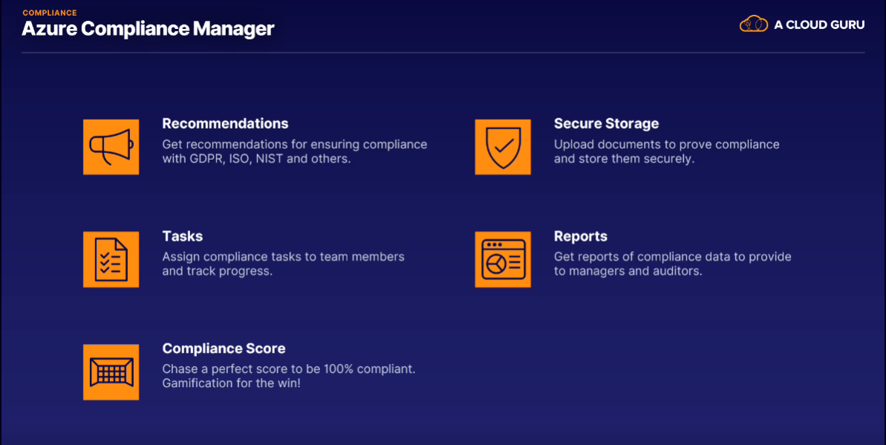

With some idea of what compliance is, who makes compliance guidelines and frameworks, and how Azure can help you manage it all, let's look at two specific Azure regions and offerings that are unique when it comes to compliance.

1. **Azure Government Cloud**

* If you are a US government body or you are contracted for one, you can get access to Azure resources in the Azure Government Cloud regions
* It has separate dedicated data centers.
* Using one of the dedicated government cloud regions gives you exclusivity.
* Compliance
* Azure benefits

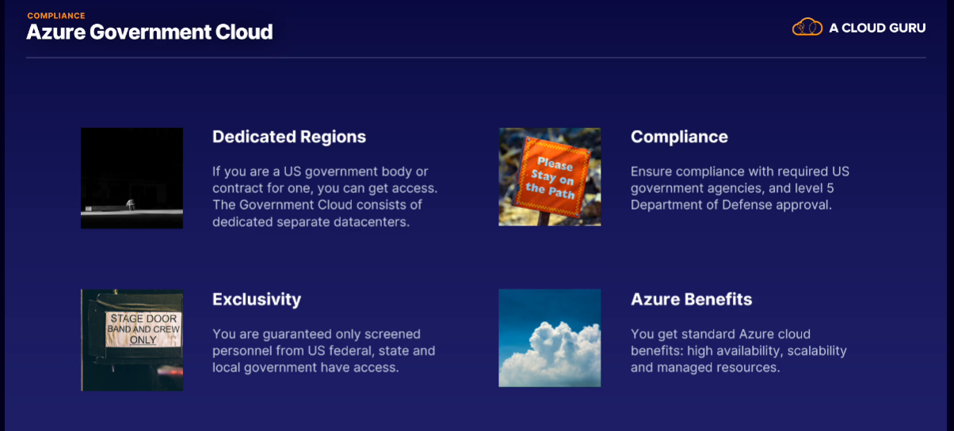

1. **China Region**

* China has very specific and strict requirements when it comes to data, internet, and online entities.
* Therefore, if you want to use Azure to provide cloud services in China, you have to use China region in Azure.
* This makes sure that your Azure resource instances are physically located in China with no connection to any other Azure regions.
* All your customer data is kept inside China at all times.
* This also means that services like Cosmos DB won't work on a global scale when China is included as a region.
* You are completely compliant with all Chinese regulations. The physical data center's even hosted by a Chinese company to ensure this.

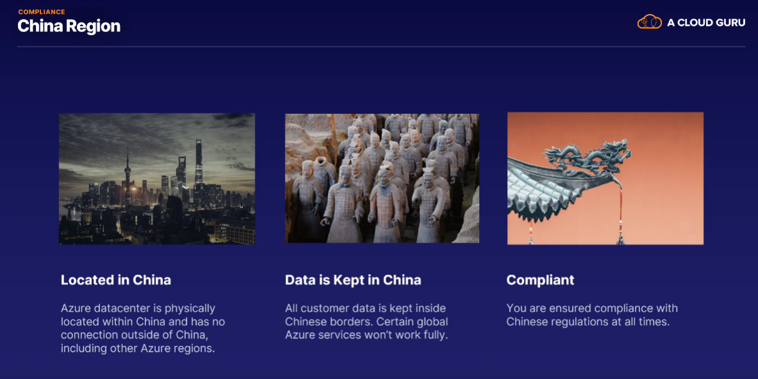

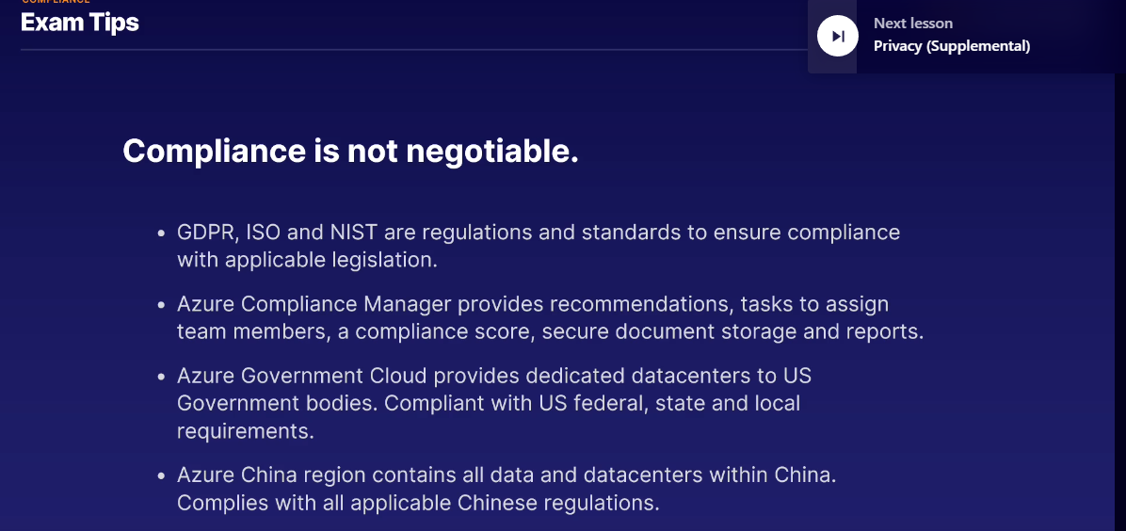

Privacy :::::

In Azure, privacy is such a core part of the platform

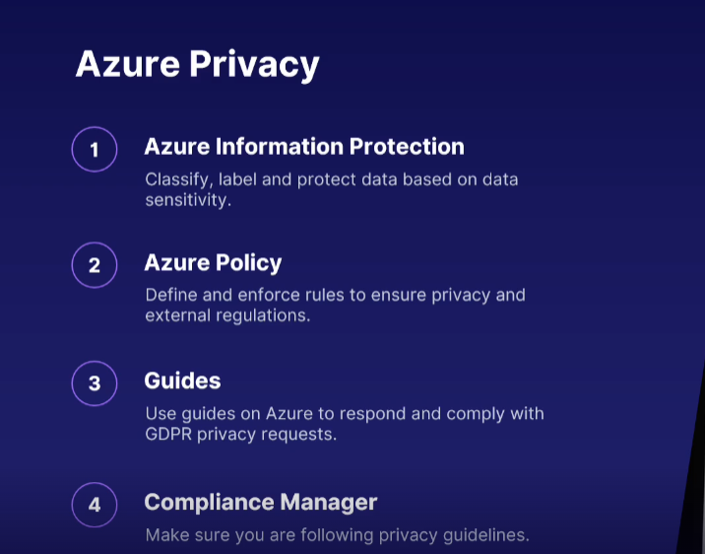

Microsoft also has their own privacy statement.

Trust ::::

There are two services on Azure that has to do with trust.

1. Trust Center

* This is a shortcut to learn about all the things Microsoft does to make sure you don't lose trust in Azure and other Microsoft services.
* There are links to learn about security, privacy, GDPR, location of your data, compliance, and more.
* The links all take you to other Azure websites that can tell you more about the security implementation, privacy dedication.

1. Service Trust Portal

* This is the location to review all the independent audit reports about Azure.
* It is their portal of proof that they're complying with a million different standards and certifications.
* It's crucial to know that Azure complies with all of the various quality and security standards. In fact, more than any other cloud provider.

Azure really wants you to trust their platform. Because without trust, there is no Azure.

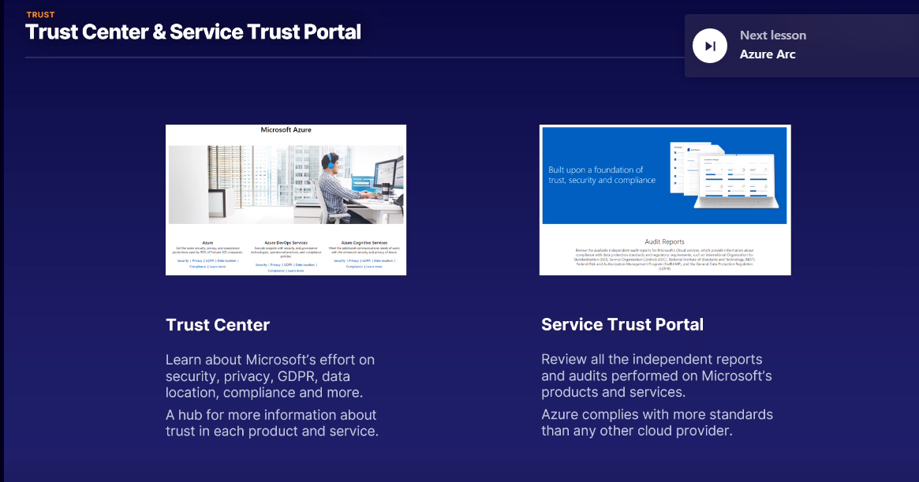

Azure Arc:::

Azure Arc simplifies the process of managing complex computing environments, whether they're in Azure or in other places, through a single unified interface.

>>> For example, a large enterprise may have computing resources in multiple locations, including Azure-based resources, computing resources and on-premises locations and data centers, and maybe even computing resources in other cloud platforms like AWS.

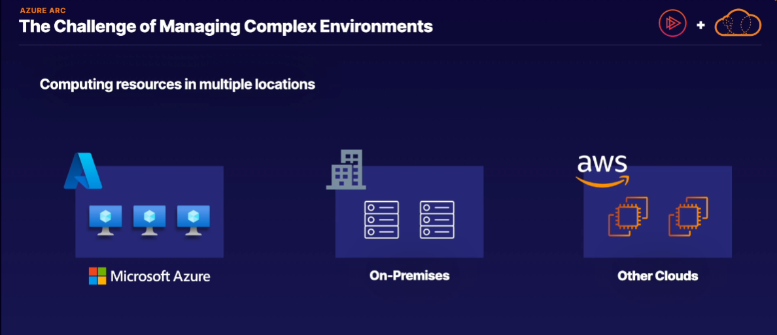

The challenge from a management perspective is that each of these computing sources has their own specific management tools.

* You use Azure management for Azure resources,
* on-premises management tools for on-premises locations,
* AWS has their own management tools as well.

More computing resources and more locations leads to more overall management overhead, and if we really like using Azure governance policies, like role-based access control, blueprints, policies and more, well, we can only apply them to Azure resources and not anywhere else.

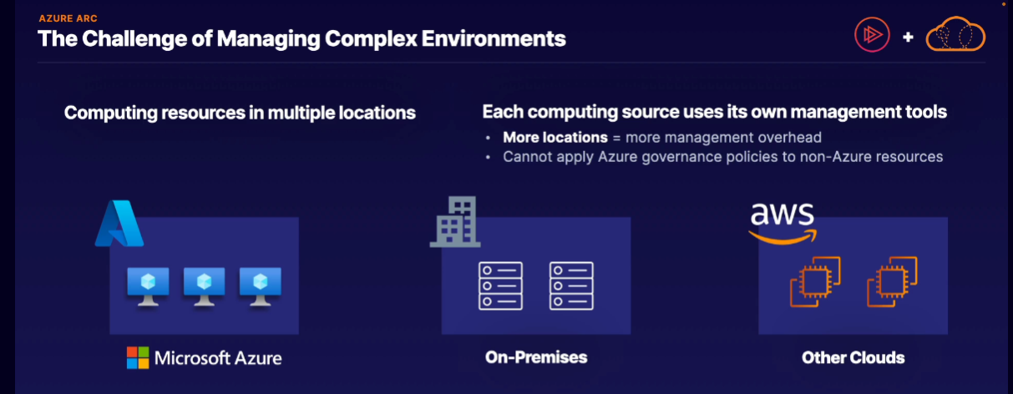

??? what if we had the ability to manage both our Azure and non-Azure resources in the same unified interface, and what if we could also apply different Azure governance policies like blueprints, policies, and others to our non-Azure resources as well?

Solution :: Azure Arc

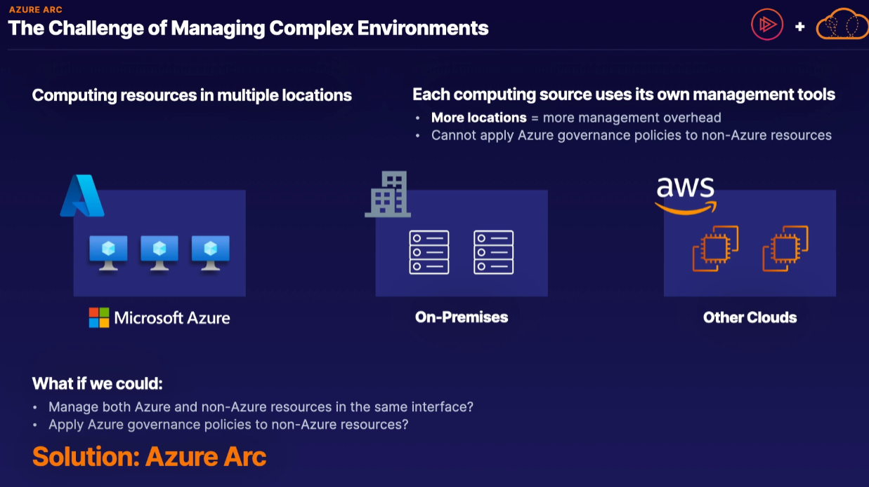

Technical definition::

Azure Arc provides a centralized governance and management for both on-premises and multi-cloud computing resources.

You can think of Azure Arc as the ability to manage both non-Azure and Azure resources as if they were all in one Azure interface or in other words, it gives you the ability to extend your Azure cloud management and Azure services to your non-Azure locations.

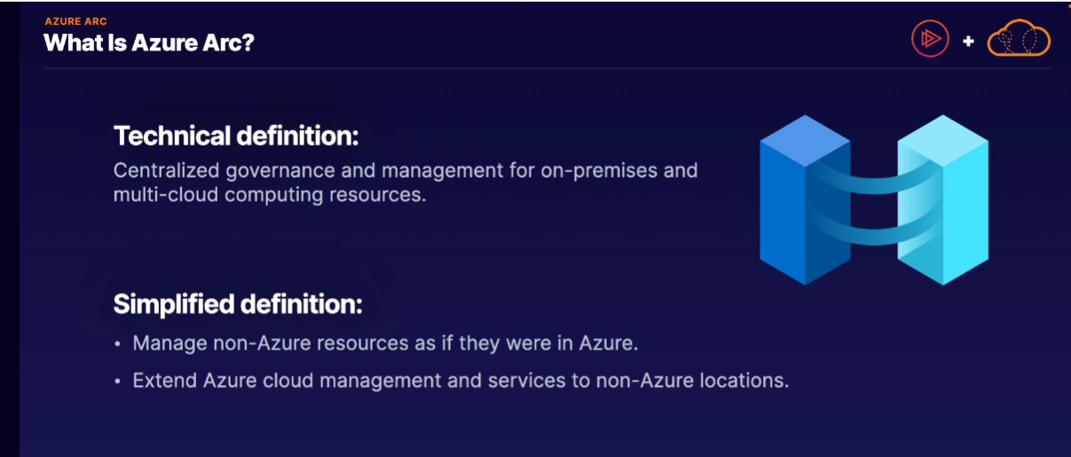

For example, we have our typical Azure environment, like you see here, in which you have a number of resources on Azure, maybe some Kubernetes clusters, virtual machines, Azure databases, et cetera, and we're managing these different resources using Azure's Resource Manager Tools, such as a single pane of glass for management, role-based access control for a fine tune access, cloud-native best practices, and different security and compliance policies, like Azure blueprints and Azure policy.

Within our Azure environment, we are able to interact with these resources through different resource manager applications, such as the Azure Portal, PowerShell, and Azure CLI.

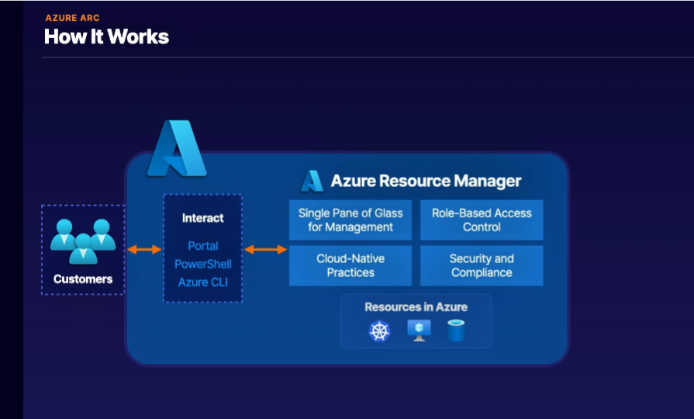

At the same time, we may have other computing resources, not in Azure, maybe in on-premises or other cloud locations, in edge locations as well. They could be Kubernetes clusters, virtual machines, databases, so on and so forth.

And by default, you manage these non-Azure computing resources with your different local management tools, again, not using Azure management tools.

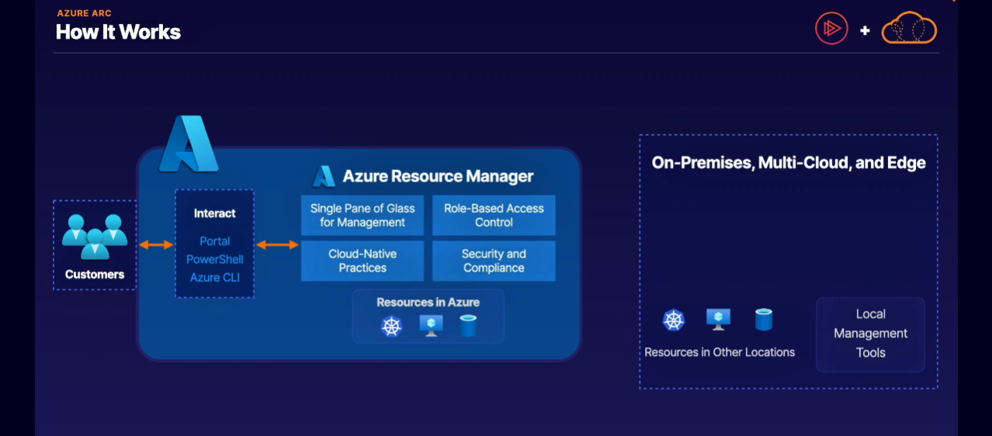

How Azure Arc works is that it effectively extends the Azure control management to our non-Azure locations. To be more specific, it works by installing an agent on these non-Azure computing resources to bring it into Azure's control plane.

As a result, your Azure access and management is effectively extended from Azure to your non-Azure resources using Azure Arc as your bridge or connection between your non-Azure locations and Azure as well.

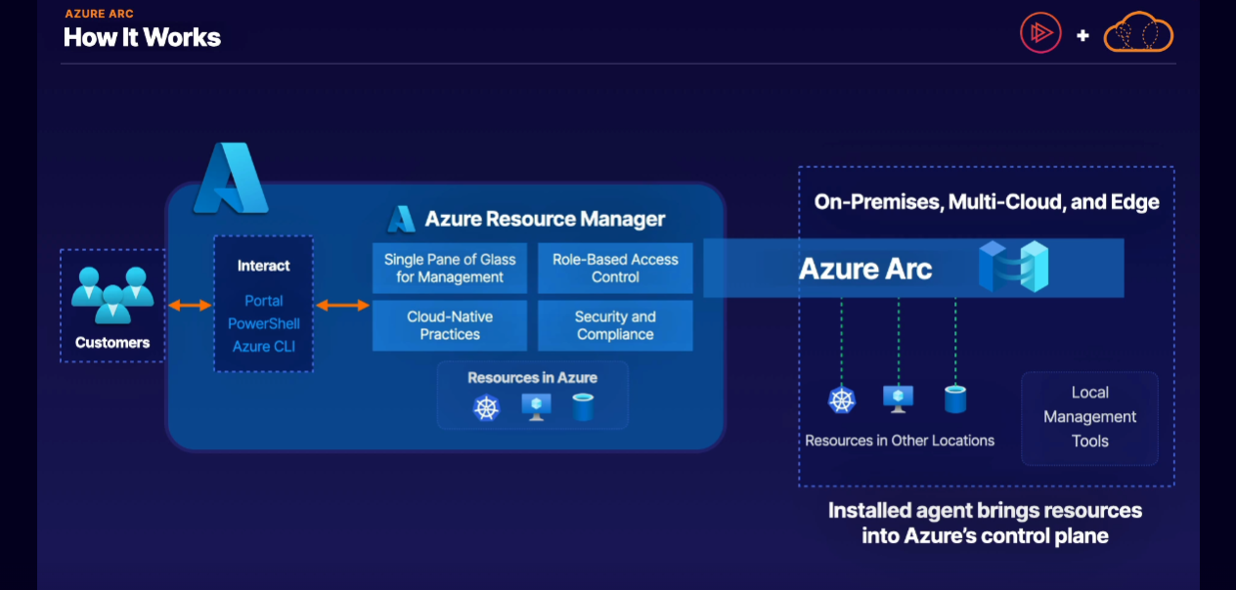

Key features::

* It allows you to manage both your Azure and non-Azure resources in the same place.
* If you work with a Kubernetes cluster, you can manage your non-Azure Kubernetes cluster alongside your Azure Kubernetes Service.
* From a data management perspective, you can deploy Azure-managed database services to your non-Azure locations, such as an Azure SQL Managed Instance, again, not within Azure.
* For individual virtual machines or servers, you can manage and protect your non-Azure services, which allow you to monitor your non-Azure operating systems alongside your Azure virtual machines.
* You can take advantage of services like Microsoft Defender for Cloud for your non-Azure locations, and you can also apply automation routines to your non-Azure resources, such as using Azure Automation runbooks.
* From a management and governance perspective, it also allows you to apply Azure governance, again, to your non-Azure resources, such as implementing role-based access control, Azure policies and Azure blueprints to your non-Azure resources.
* You even have the ability to deploy Azure serverless services to your non-Azure hardware, specifically non-Azure Kubernetes clusters, in which you can deploy the Azure App Service service, Azure Functions, Azure Logic Apps and other Azure serverless services to your non-Azure locations.

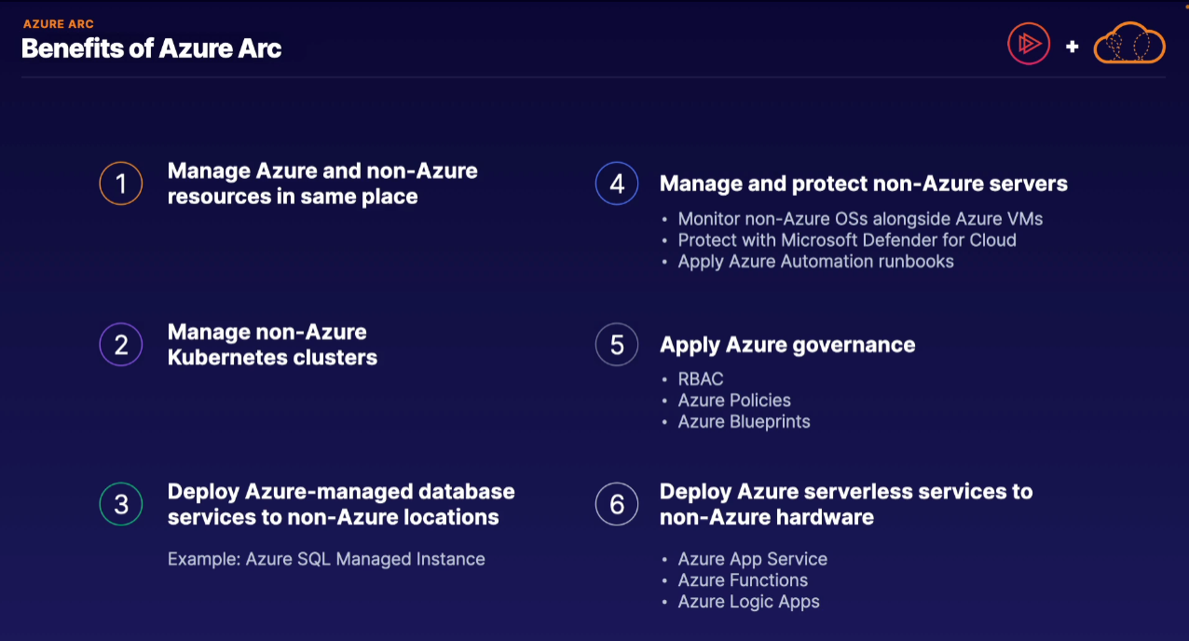

Let's say in this scenario that we have a large complex environment in which you maintain service in both Azure and an on-premises data center.

However, you have a requirement in which you need to apply different Azure management policies, like Azure blueprints, Azure policies and Azure role-based access control to these non-Azure based servers.

